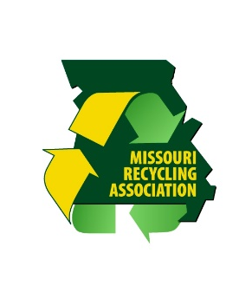
Missouri Recycles Day 2015

Proclamation by the Governor of Missouri Establishing
November 15, 2015 as Missouri Recycles Day

Whereas, the (State of Missouri … City of XXX …, XXX County) recognizes the importance of protecting and preserving our natural resources and adopting conscientious habits that will improve our daily lives and bring about a cleaner, safer and more sustainable environment; and
Whereas, Missouri has achieved a 57% diversion rate, we must focus on other initiatives such as waste reduction, composting, the reuse of products and materials, and purchasing recycled content products as we strive for a 75% diversion rate; and
Whereas, by encouraging businesses, state agencies, nonprofit organizations, schools and individuals to celebrate Missouri Recycles Day 2015, we can further promote recycling as an environmentally efficient and economically smart habit; and
Whereas, state, county and community leaders can help encourage recycling by informing citizens about local recycling options, they can also foster greater awareness of the need to expand collections programs by promoting the benefits of recycling, encourage recycling infrastructure and business development; and
Whereas, it is important that all Missouri citizens become involved in recycling activities and learn more about the many recycled and recyclable products available to them as consumers; it is also fitting to celebrate Missouri Recycles Day 2015 and take action by educating citizens to participate in the recycling options available in our community;

Now, therefore, I (Governor Jay Nixon … County Commissioner XXX …, Mayor XXX) do hereby recognize November 15, 2015 as Missouri Recycles Day

